Light bulb moment

Harry and Emily have drawn pictures of a glowing bulb.
They have added rays to show how light moves from the bulb.

a. Which drawing best shows how light moves from the bulb?

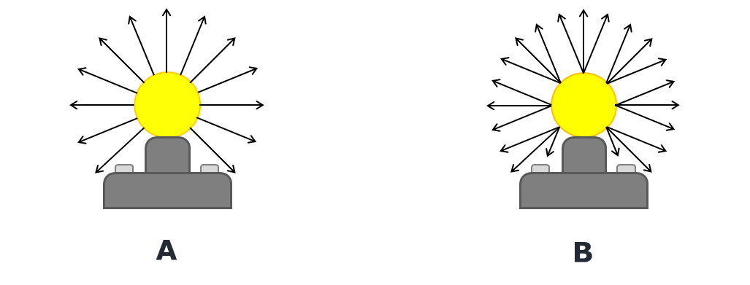

b. What is the best reason for your answer?
Put a tick (✓) in the box next to the best answer.
A | Light from the bulb can make shadows
B | The bulb can be seen from all directions
C | Light moves away from the bulb

Physics > Big idea PSL: Sound, light and waves > Topic PSL3: Making images > Key concept PSL3.1: The ray model of light to explain images
Diagnostic question
Light bulb moment

Overview
Learning focus: | Only some light rays from each point of an illuminated object can pass through a pinhole, hitting a screen at distinct points to make an inverted image.
Observable learning outcome: | Describe how light rays are emitted from each point on an extended light source.
Question type: | Two-tier multiple choice
Key words: | Light ray

What does the research say?
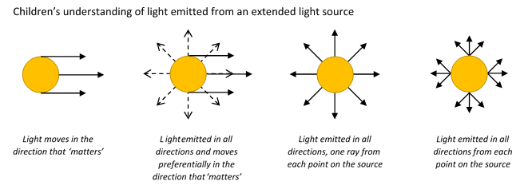
Galili and Hazan (2000) found over half of 14- to 16-year-olds (n=166) consider rays to be actual physical things that are the constituents of light. The fact that rays are imaginary lines that show the direction in which light is travelling is rarely made explicit in teaching (Andreou and Raftopoulos, 2011).
Students’ understanding of image formation is largely dependent on the way they perceive light emission from extended light sources. Rice and Feher (1987) found when students are presented with a lamp in front of an optical device (pinhole, mirror, prism, lens) about half of 9- to 13-year-olds (n=62) described light rays moving parallel to each other from the light source in a ‘preferred direction’ towards the device. This view was maintained even when a cylindrical lamp was used that clearly lit the room in all directions. In Galili and Hazan’s study 40% of students aged 14-16 had the misunderstanding that just one ray was emitted from each point on a light source.
In order to explain image formation students need to understand that a light is emitted in all directions from each point on the source (Rice and Feher, 1987; Dedes and Kanstantinos, 2007; Galili and Hazan, 2000; Andreou and Raftopoulos, 2011).
Ways to use this question
Students should complete the questions individually. This could be a pencil and paper exercise, or you could use an electronic ‘voting system’ or mini white boards and the PowerPoint presentation. The follow on question will give you insights into how they are thinking and highlight specific misconceptions that some may hold.
If there is a range of answers, you may choose to respond through structured class discussion. Ask one student to explain why they gave the answer they did; ask another student to explain why they agree with them; ask another to explain why they disagree, and so on. This sort of discussion gives students the opportunity to explore their thinking and for you to really understand their learning needs.
Differentiation
You may choose to read the questions to the class, so that everyone can focus on the science. In some situations it may be more appropriate for a teaching assistant to read for one or two students.
Expected answers
a. B – light is emitted in all directions from each point on the source
b. B - the bulb can be seen from all directions
How to respond - what next?
Galili and Hazan (2000) found 37% of students aged 14-16 drew pictures of light emitted from an isolated source as straight lines radially expanding from it, and this increased to 44% after teaching. Pictures of rays of light from the Sun or torch beams can reinforce this misunderstanding.
Students selecting picture A may think that just one ray originates at each point on the bulb and are likely to select either reason A or C. Reason A is a subtle version of the misunderstanding that light has a preferred direction in which it moves.
Picture B shows an extended light source that can be seen from all directions because light travels from each point on its surface in every direction. Light has to travel from the bulb into the eye in order to be able to see it. For this reason picture A does not explain how the whole of the bulb is seen from any one position.
Both pictures show light moving away from the bulb and also how shadows can be produced. The shadows made by extended sources however can produce half-shadows (penumbra) behind an object where some, but not all, of the light from a bulb reaches. Multiple rays from each point on a source are necessary to show how half-shadows form.
If students have misunderstandings about how light moves away from a bub, it can help to discuss how we can see a bulb from multiple directions. Asking students to draw diagrams to show how light from each part of the bulb reach the eyes of observers observing the bulb from different directions can illustrate what happens and consolidate understanding.
Acknowledgments
Developed by Peter Fairhurst (UYSEG).
Images: Peter Fairhurst (UYSEG).
References
Andreou, C. and Raftopoulos, A. (2011). Lessons from the history of the concept of the ray for teaching geometric optics. Science and Education, 20, 1007-1037.
Dedes, C. and Kanstantinos, R. (2007). Teaching image formation by extended light sources: the use of a model derived from the history of science. Research in Science Education, 39, 57-73.
Galili, I. and Hazan, A. (2000). Learners' knowledge in optics: interpretation, structure and analysis. International Journal of Science Education, 22(1), 57-88.
Rice, K. and Feher, E. (1987). Pinholes and images: childres's conceptions of light and vision. Science Education, 71(4), 629-639.

